BIOC 300D Lecture #3
Dr. Philippe Gros
February 5th, 2007

Lecture #3: Episomes

Episomes – foreign DNA that can be replicated in a host separately from its own chromosomes. Two types of importance for the lab are plasmids and bacteriophages.

Common features of episomes
- small circular DNA or RNA genomes
- capable of autonomous replication, asynchronously from the replication of the host genome
- They act as genetic parasites
- They can also integrate and excise themselves into and from the host genome

Bacteriophages have a set of enzyme that permit the integration or they can be using some of the host machinery to integrate. When they excise themselves from the host genome, sometimes it is imperfect. Some of the episome is left behind in the host genome, while some of the host DNA replaces the lost fragment of the episome DNA. This additional genetic information acquired by the episome can be passed to a new host upon re-infection by the recombinant episome.

Why do we care about episomes?
One of the reasons: Episomes often code for proteins that confer specific selection advantage (antibiotic resistance) that allows the infected host survive under certain unfavourable conditions.

Bacteriophages
- Viruses that infect bacteria
- Can have double stranded or single stranded genomes composed of either DNA or RNA
- Continuous or fragmented genome
- Segment of nucleic acid incapsulated in a protein code
- Can be very simple or complex – great diversity
- Estimated number in biosphere - 10³¹
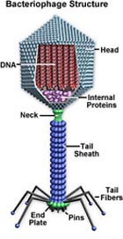
- Cannot replicate on its own – strict parasite
- Act as insertional mutagens because they can disrupt the host genome – dynamic modulators of bacterial ecosystems

Structure (See figure on the right)

  - Composed of the head, tail and tail whiskers
  - Well defined three-dimensional head structure
  - Syringe-like tail, which can contract to ‘inject’ DNA into the host cell
  - The ends of whiskers have enzymes that are able to digest the cell wall of bacteria in a specific manner to be able to anchor the phage on the host

There are two types of phage:

- Lytic (virulent) phage
Suicide pathway – infect, kill and lyse the host until all the bacteria die, at which point the phage become non-functional as they are unable to replicate without the host
Eg. Bacteriophage T4 (used in Lab 9)
- Temperate phage
  - Able to go into the lytic phage
  - Also able to integrate itself into the host genome and propagate silently without being noticed
  - Can remain dormant

Steps of the lytic cycle (Figure on the right)
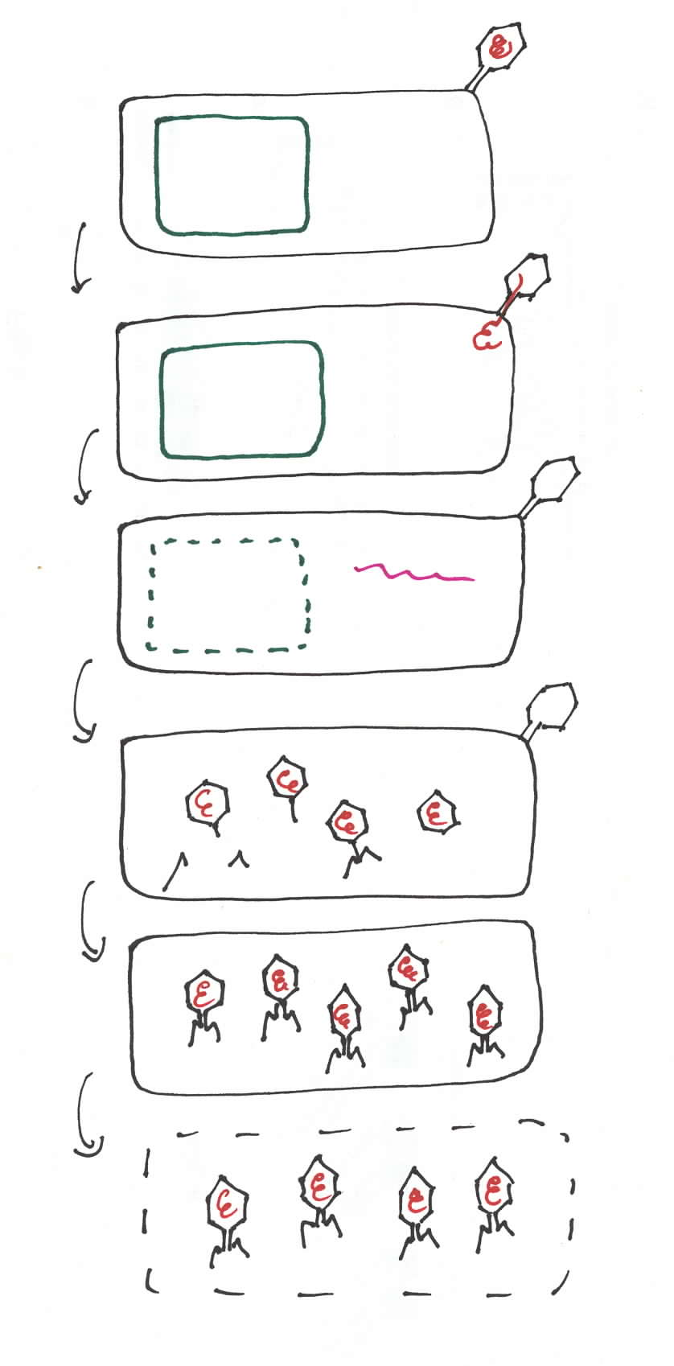
- Adsorption of the phage into the cell, at the specific attachment site (att). The phage punctures the cell wall.
- Phage DNA is injected into the host
- The phage DNA is replicated, first proteins, such as nucleases, are synthesized, host DNA is digested.
- The rest of the viral proteins are synthesized, the new generation of phage are assembled.
- The late proteins, such as lysins and holins, which degrade the bacterial cell walls, are synthesized.
- The host is lysed and the phages are released into the environment.

This cycle takes 20 to 25 minutes.

The Growth Curve
When the number of phage in a colony is counted and plotted as a function of time, a growth curve with a characteristic sigmoid shape is produced, as shown on the diagram below.

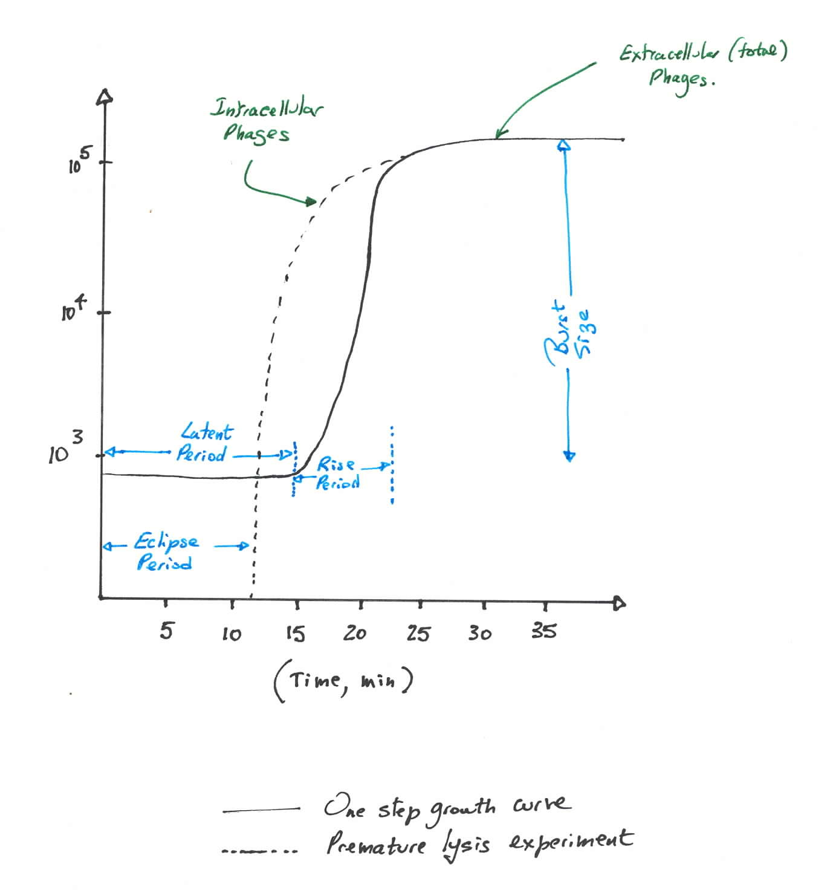
The first flat portion of the curve corresponds to the time required for the phage to replicate inside the host cells.

The sharp rise represents the point of the growth cycle when the host cells begin to lyse and released the new phage into the environment.

Subsequently, the newly released phage re-infect surrounding cells and the cycle repeats.

Important terminology:

Eclipse period – time between the infection and the synthesis of the first live bacteriophage

Latent period – time between the infection and the appearance of the first extracellular phage. There are two different techniques that will allow to differentiate the eclipse and latent periods – one-step growth and premature lysis experiments. In one-step, the cells are infected, allowed to lyse naturally and the phage are counted, from which the latent period can be visualized. In the premature lysis experiment, the cells are lysed with chloroform, which releases the phage, which would otherwise still be inside the host. Thus, the eclipse period may be calculated.

Rise period – the period of active phage production during a single round of infection

Burst size - mean number of the phage released per bacterium

Steps in the growth cycle of a temperate phage (Figure on the right)
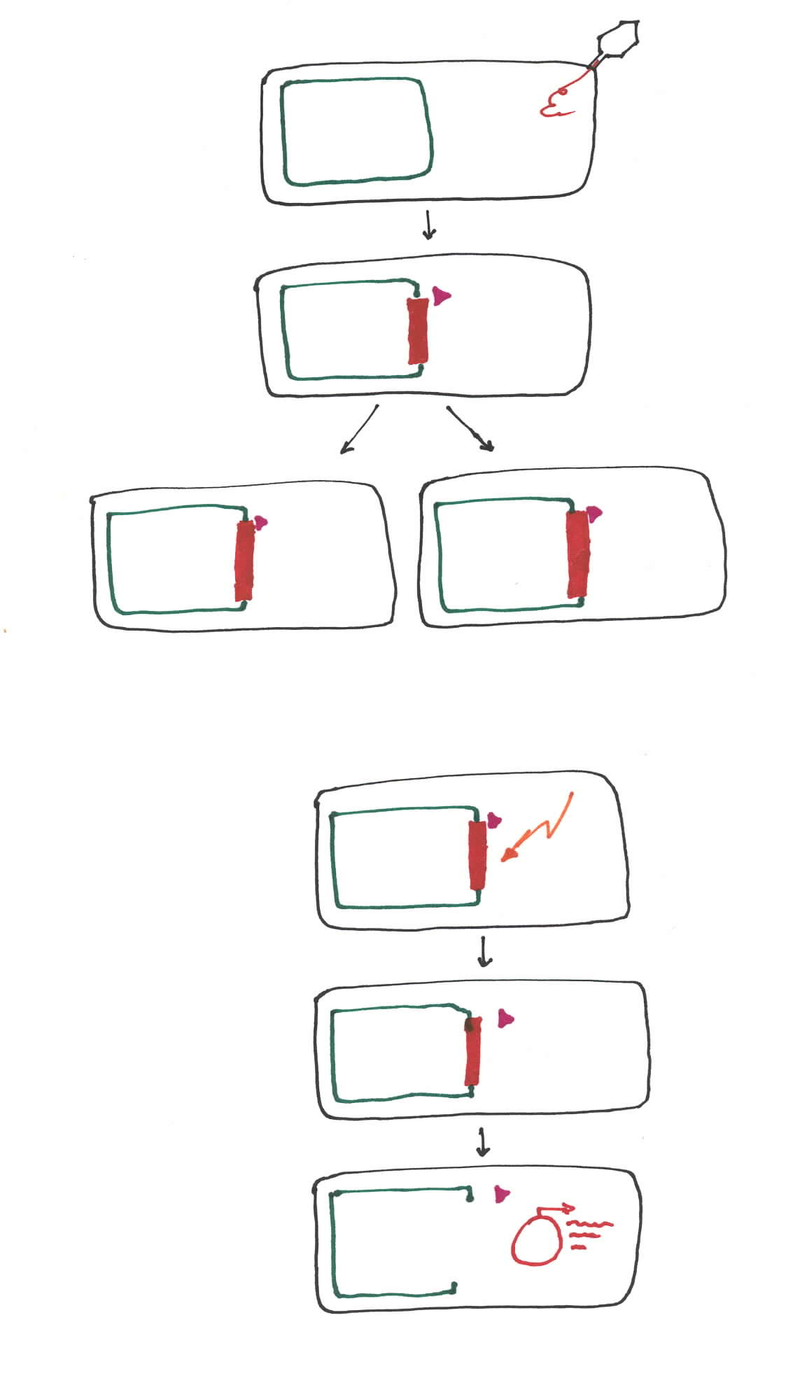
- Phage penetrates the host
- The phage DNA is replicated rapidly and integrated into the host genome. Repressors are synthesized to avoid expression of the lysis proteins to prevent the cells going into the lytic cycle.
- The phage DNA is replicated with the host. Such host is referred to as lysogenic strain.
- Upon a certain induction signal, which usually disturbs bacterial DNA (UV, nutrient conditions etc), the prophage, or the first phage, is produced.
- The repressor is degraded, and the phage is able to enter the lytic cycle.

Note: It is possible that imperfect excision of the prophage occurs, resulting in a recombinant host and phage genomes. As mentioned above, this may result in a transmission of certain growth advantages between two different hosts.

Example: Baccteriophage K, large genome because it carries its own replication machinery in its genome.

Applications of Bacteriophages
- Construction of genomic libraries
  - the bacteriophage lambda genome contains a stretch of approximately 20 kbp in its genome responsible for the lysogenic functions
  - this DNA can be replaced by foreign DNA
  - if multiple phages are constructed in this manner, it is possible to obtain a library of an organism’s genome
- Sequencing
  - these fragments can be used to sequence the organism’s genome (Contig sequencing)
- Insertional mutagenesis
  - use of phages allows to disrupt a specific gene in the bacterial genome and select for the infected bacteria
- Expression of proteins
  - Since the replication of phages inside the host requires rapid production of proteins, phages have very strong up-regulating sequence
  - If these sequences are fused with a protein of interest (eg. insulin), it can be synthesized quickly inside bacterial hosts
- In vivo phage therapy
  - Phage proteins may be used to destroy certain harmful hosts in vivo
  - Eg. Anthrax-infected mice were cured by the holin protein of a bacteriophage which targets Anthrax bacillus
- Discovery of bacterial targets
  - Companies observe the targets of attack of phage on bacteria to manufacture drugs that mimic the attack on the same targets

IMPORTANT EXPERIMENTAL NOTES:
Plaque assay
  - a way to enumerate bacteriophages in a solution
  - the number of plaques, or zones of clear lysis, formed on a confluent lawn of bacteria is measured
  - this number represents the number of plaque forming units in a solution
  - it is important to make sure that each infected bacterium carries only one phage, so that each plaque corresponds to a single phage. This is done by using a very dilute phage solution.

Soft agar – very important to keep the temperature around 40°C. Higher temperatures will kill the bacteria, while the agar will solidify at lower temperatures.

